Computer Network lab
Name: Ayush Ravindra Patil
Date: 10-09-26
Practical: 4

1] CRC (Cyclic Redunduncy Check):

# Algorithm:
Step 1) Start
Step 2) Take input dataword and polynomial
Step 3) Convert the polynomial into bits and calculate redunduncy.
Step 4) Concatenate dataword and redunduncy bits
Step 5) Perform Modulo – 2 Division on Sender side with dataword and divisor
Step 6) Contenate the remainder at LSB with datawords
Step 7) Perform X-OR division on receiver side with the dataword from sender’s result and divisor
Step 8) If the remainder is 0, then accepted, otherwise discard the operation.
Step 9) Stop

2] Code:

def xor_division(bits, generator):
data = list(bits)
gen = list(generator)
# Loop through the data string up to the point where the generator fits
for i in range(len(data) - len(gen) + 1):
# In Modulo-2, we only XOR if the leading bit of the current window is '1'
if data[i] == '1':
for j in range(len(gen)):
# Perform XOR logic on the current window of bits
data[i + j] = str(int(data[i + j]) ^ int(gen[j]))

# Return the remaining bits (the remainder)
return ''.join(data[-(len(gen) - 1):])

print("Sender's side")
dataword = input("Enter dataword bits: ")
generator = input("Enter generator bits: ")
print("\nDataword :", dataword)
print("Generator:", generator)

zeros = '0' * (len(generator) - 1)
padded_data = dataword + zeros
print("Padded data : ", padded_data)

crc = xor_division(padded_data, generator)
print("CRC :", crc)

codeword = dataword + crc
print('Codeword :', codeword)

print("\nReceiver's Side:")
received = input("Enter received bits: ")
receiver_remainder = xor_division(received, generator)
print("Receiver remainder:", receiver_remainder)

if receiver_remainder == '0' * (len(generator) - 1):
print("Result: no error detected")
else:
print("Result: error detected")

3] Output:

- If Correct:
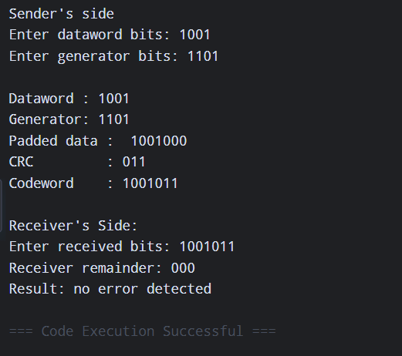

- If Incorrect:
